**Project Design Phase-II**

**Data Flow Diagram & User Stories**

|  |  |
| --- | --- |
| Date | 01 March 2025 |
| Team ID | SWTID1741250529149916[Team-149916] |
| Project Name | Insight Stream |
| Maximum Marks | 4 Marks |

**Data Flow Diagrams:**

A Data Flow Diagram (DFD) is a traditional visual representation of the information flows within a system. A neat and clear DFD can depict the right amount of the system requirement graphically.

**Example:**

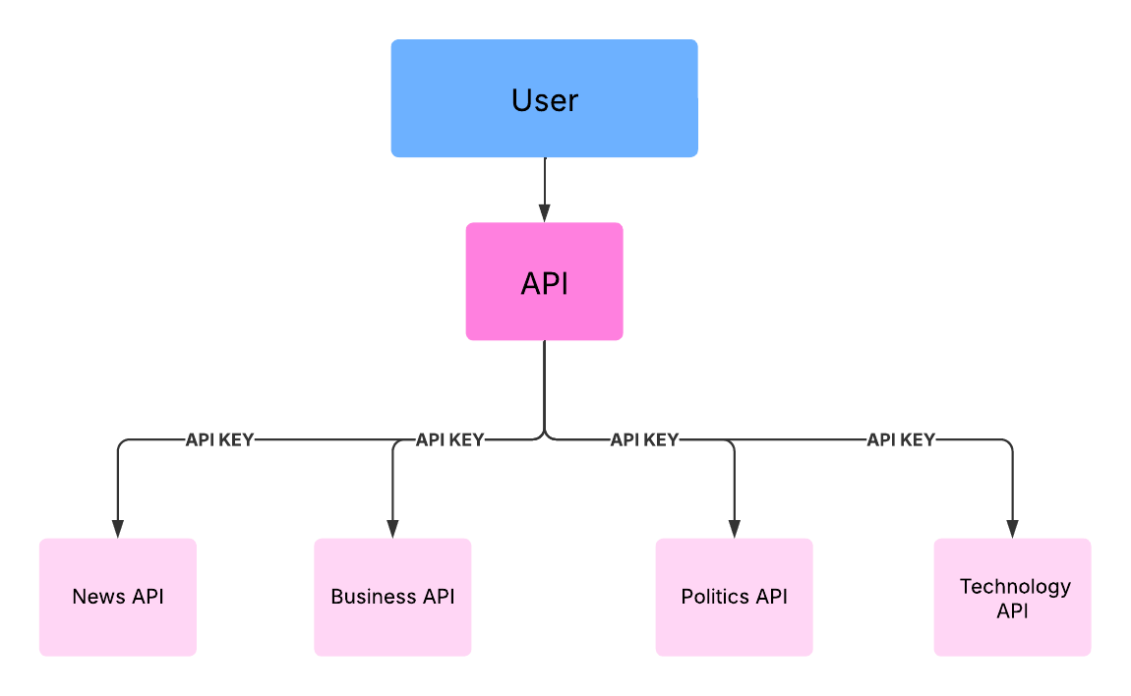

**User Stories**

**User Story Table – Music Streaming App**

|  |  |  |  |  |  |  |
| --- | --- | --- | --- | --- | --- | --- |
| **User Type** | **Functional Requirement (Epic)** | **User Story Number** | **User Story / Task** | **Acceptance Criteria** | **Priority** | **Release** |
| **News** |  | USN-1 | As a user, I can see the trendy news . | I can see the News of all topics. | High | Sprint-1 |
| **Genre** |  | USN-2 | As a user, I can watch Political,Business, and Technology News. | I can also go the source and read the full news. | High | Sprint-1 |
|  |  | USN-3 | As a user, I can able to view the complete news across the world. | I can also watch the news for multiple pages . | Medium | Sprint-2 |
| **Subscription** |  | USN-4 | As a user, I can even subscribe. | I can Subscribe to the newsletter for the news . | High | Sprint-2 |